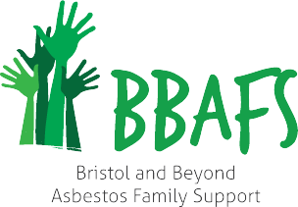

BBAFS offers friendship, support and information for all those affected by mesothelioma and other asbestos related diseases, including their carers, families and friends, all are welcome!

We meet on 2nd Thursday of every month at The Art Room, Brackenwood Plant & Garden Centre, Pill Rd, Bristol BS8 3RA, for a friendly cuppa and chat with speakers and events on various dates – see website for up to date information.

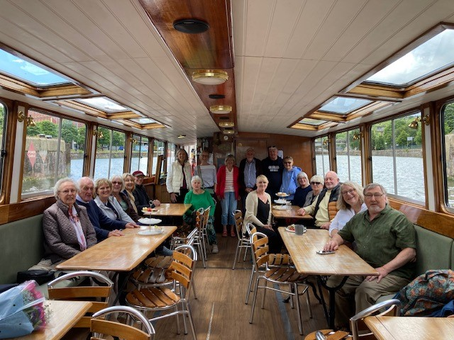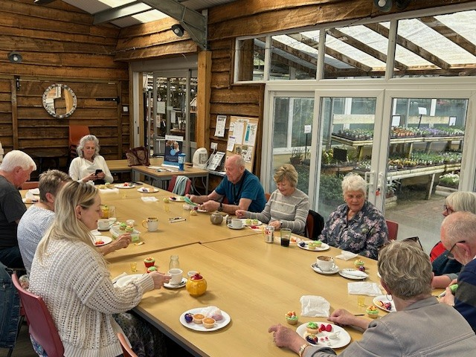

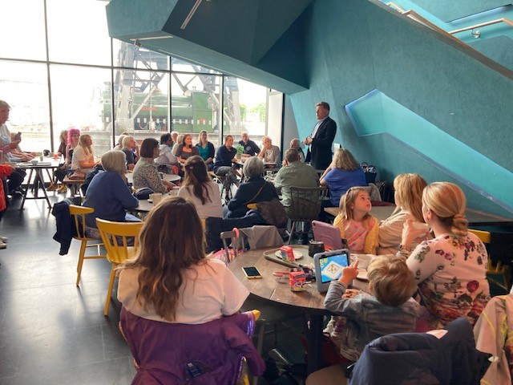

Please note that we ask you not to attend the support group if you are feeling acutely unwell and it is your responsibility to make your own way there and back.
Disabled parking and facilities are available at Brackenwood Garden Centre.
Please ensure you let any allergies known to staff leading the support group.
In the unlikely event that the room is full, we may ask you to come back later.

BBAFS Support Group dates for 2026

Thursday, 8th January 2026 at 13:30
Thursday, 12th February 2026 at 13:30
Thursday, 12th March 2026 at 13:30
Thursday, 9th April 2026 at 13:30
Thursday, 14th May 2026 at 13:30
Thursday, 11th June 2026 at 13:30
Friday, 3rd July 2026 at 10.30 – Action Mesothelioma Day
MShed Café, Bristol Harbourside
Thursday, 13th August 2026 at 13:30
Thursday, 10th September 2026 at 13:30
Thursday, 8th October 2026 at 13:30
Thursday, 12th November 2026 at 13:30
Thursday, 10th December 2026 – Christmas Lunch TBC

If you have any questions, please contact us on
Email: bristolandbeyond1@gmail.com or
Tel: 0117 414 1027 (Anna Morley, Mesothelioma UK nurse)
Email: anna.morley@nbt.nhs.uk

Further information is on our website: www.bristolasbestossupport.co.uk

